**NAME: P.NITYASREE**

**REGNO: 17MIS1007**

**COURSE: INFORMATION SECURITY MANAGEMENT**

**COURSE CODE: CSE 3502**

**FACULTY: ANUSHA**

**LAB EXERCISE-10**

**EXPLOITS:**

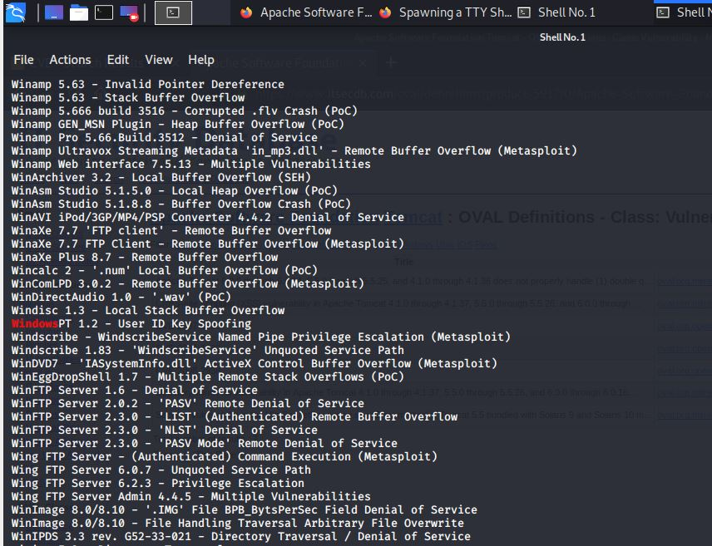

1. **The ls command**

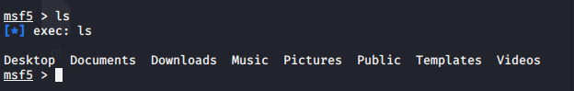

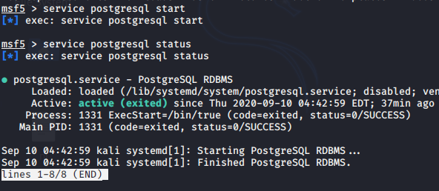

1. **START COMMAND**

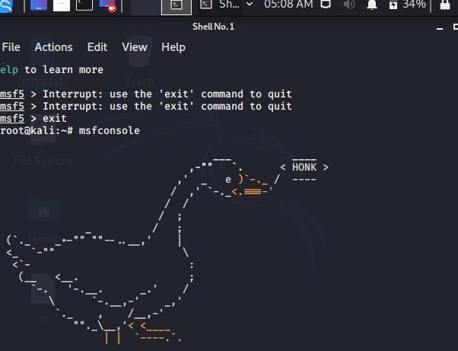

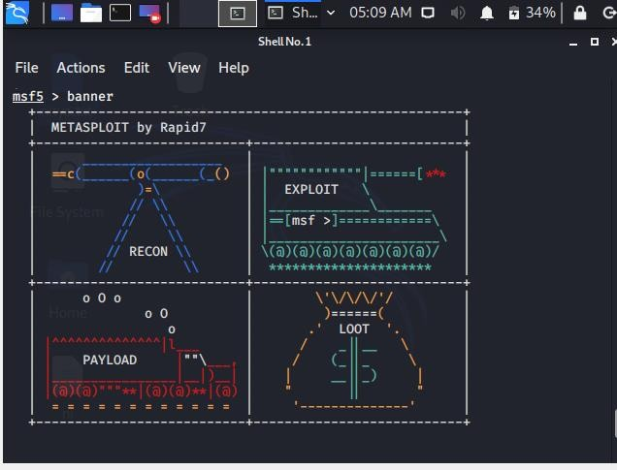

1. **ALL THE BANNER AND VERSION COMMANDS**

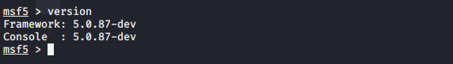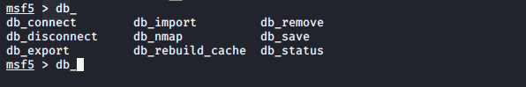

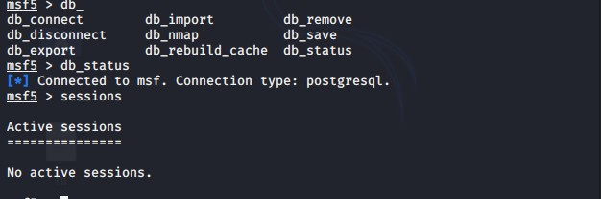

1. **THE REVERSE_TCP COMMAND**

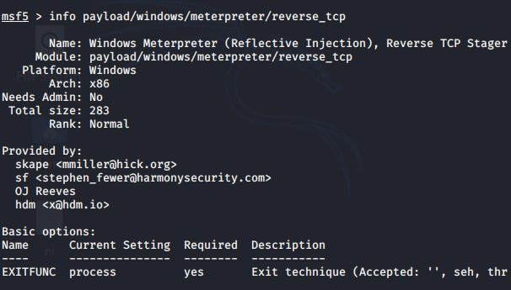

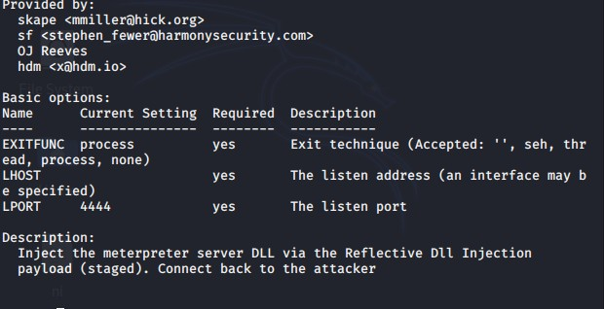

1. **THE FRAMEWORK COMMAND**

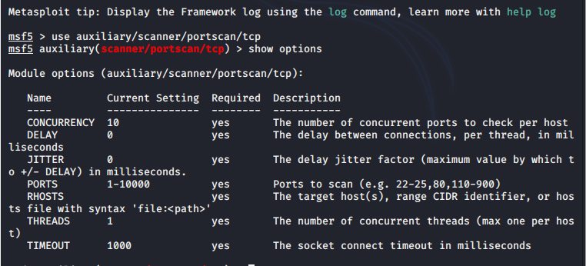

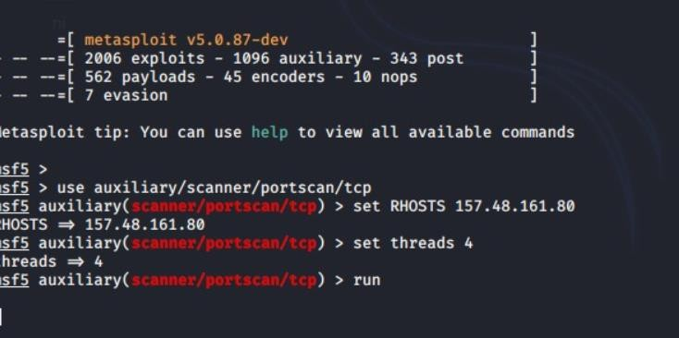

1. **THREADS ,RHOSTS COMMAND AND RUN COMMAND**

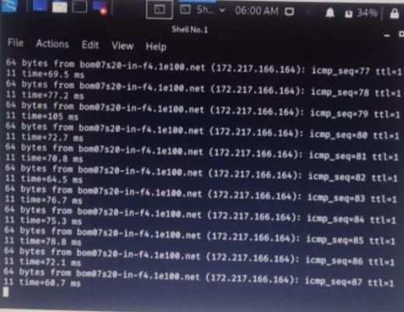

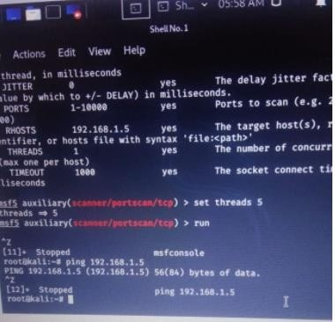

1. **SEARCH Vsftpd 2.3.4**

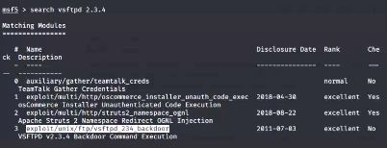

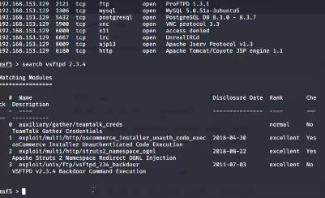

1. **BACKDOOR METASPOLIT EXPLOITATION:**

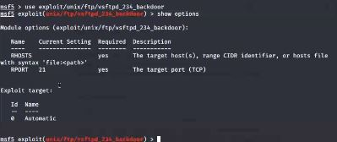

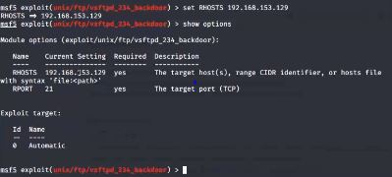

1. **SET RHOSTS 192.168.152.139**

**SHOW OPTIONS**

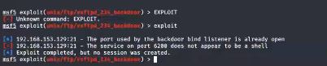

1. **EXPLOIT :**

